**PAATHSHALA**

**Introduction:**

With the rapid growth in technologies mobile applications have become a vital part in student’s life. So, mobile apps can be used to help students excel in their academics. For example, in many scenario students are not able to attend regular classes which leads to students lagging behind in their studies. Paathshala is an android application which helps students find instructors which in fact can be the students themselves who can help others with their studies in person, which results in better understanding of concepts compared to e-learning.

**Motivation:**

* It is difficult for students to grasp each and every concept which is taught in the class in such a limited span of time.
* It becomes quite difficult for teachers to entertain doubts of each individual in the class.
* Face to face learning has always been as compared to e-learning.
* E-learning does not resolve doubts of students efficiently.
* Finding the right tutor that can engage and inspire, can really make a big difference for the learner.

**Technologies:**

* Firebase
* for storing and retrieving data
* for authentication
* Cloud Messaging for implementing cross platform messaging
* Realtime database for synchronizing data
* Storage for uploading and downloading files
* Android Studio 3.5.1 - for developing android app.

**Features:**

* Interactive app for users willing to teach and learn.
* Platform for skilled people ready to deliver their knowledge.
* Global chat for group discussions.
* Private chats between instructor and students.
* Dynamic Dashboard.
* View pager which shows the upcoming courses.
* Students can find instructors on the basis of subjects and instructors.
* Students can keep track of the upcoming and ongoing courses.
* Students can register in various courses.
* User can see courses taken by them, courses published and completed courses.
* User can give ratings and submit feedback for app.
* Instructor can post new course, view, edit and delete courses.

**Installation:**

1. Download the zip folder of Paathshala app.
2. Unzip the folder to extract the files.
3. Open the folder in android studio.
4. Run the app.

**References:**

1. Firebase:

<https://developer.android.com/studio/write/firebase>

1. List view:

<https://www.javatpoint.com/android-custom-listview>

1. Login and forgot password:

<https://www.youtube.com/watch?v=V0ZrnL-i77Q>

1. Time picker: <https://www.tutorialspoint.com/android/android_timepicker_control.htm>
2. Date picker:

[https://www.tutorialspoint.com/android/android_datepicker_control.htm](https://www.tutorialspoint.com/android/android_timepicker_control.htm)

1. File uploading in firebase:

<https://www.youtube.com/watch?v=XOf_v2f85RU>

**Demonstration of our app:**

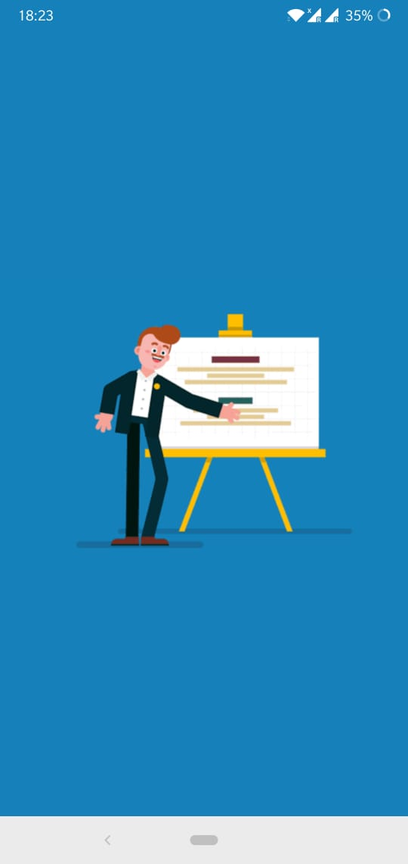

**Splash screen**

This is the first page of our application.

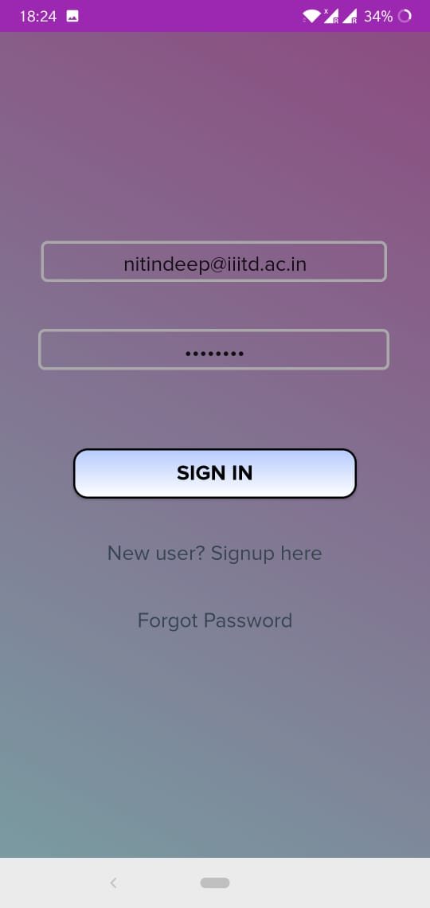

**Login Page**

Registered users can sign in in the app with the help of email id and password.

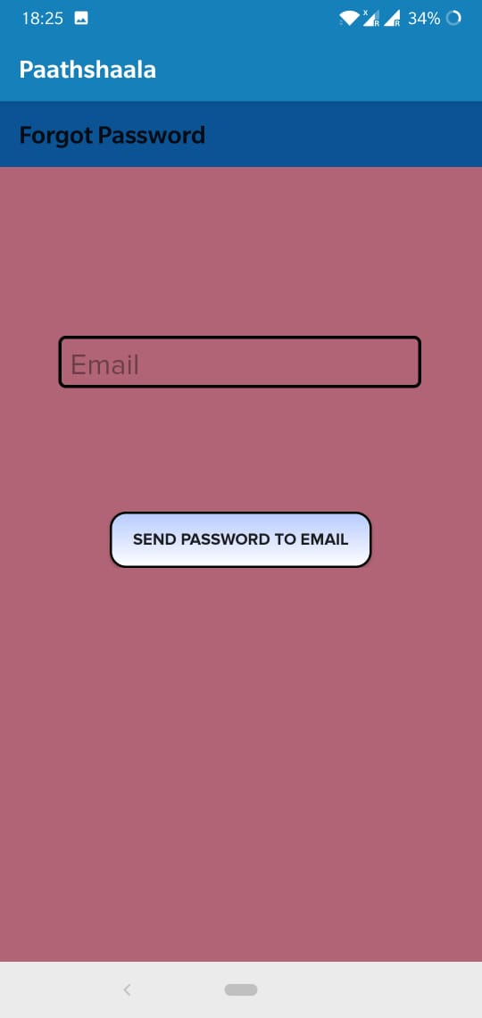

**Forgot Password**

New user can opt for ‘Signup’ option. If a user has forgotten his password then he/she can go for ‘Forgot Password’ option. Any registered user who has forgotten the password can request for new password with the help of this page. A new password will be sent to the user. A new user can register or create a new account by filling in the details in the signup page.

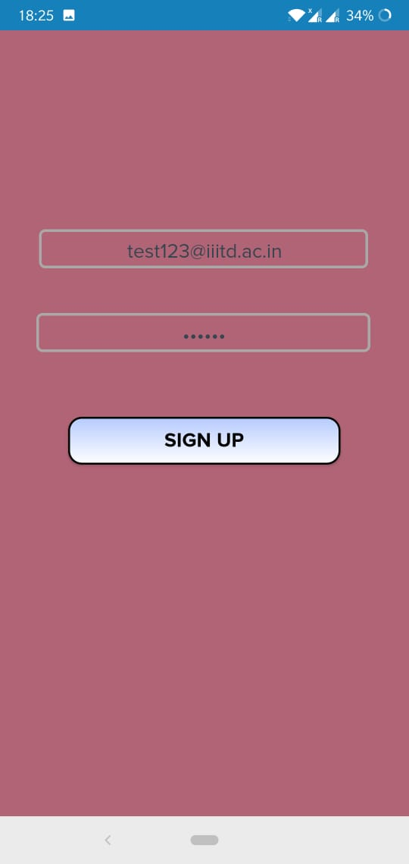 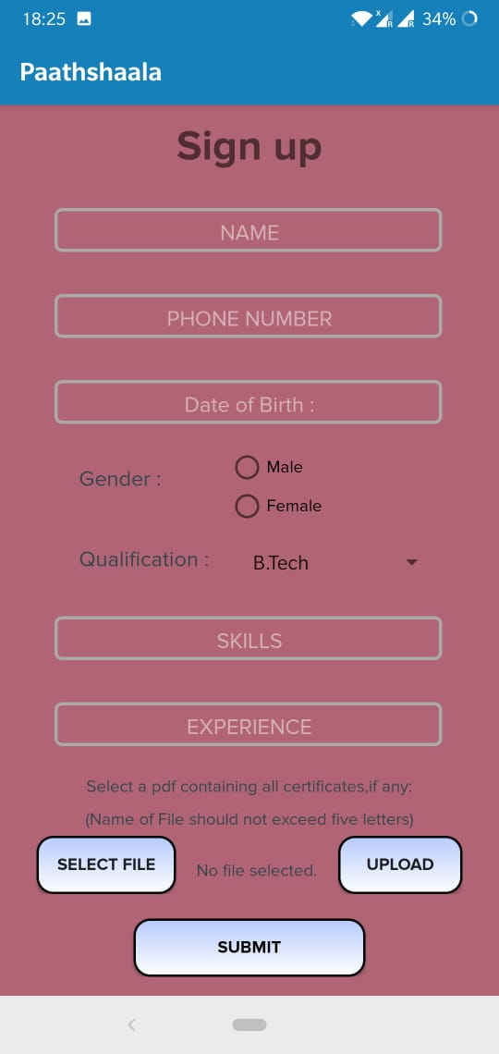

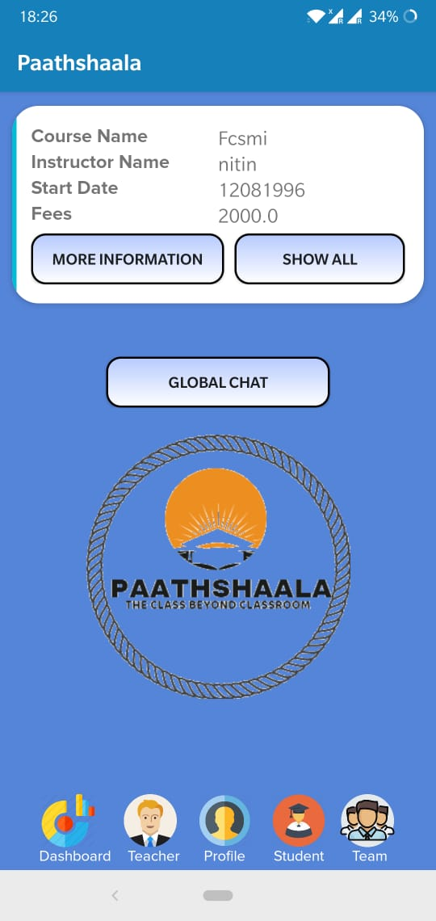

**Home Screen**

This page contains all the upcoming courses in which student can enrol. Users can get more detailed information by clicking ‘MORE INFORMATION’. The user can also access the ‘GLOBAL CHAT’ from this page. It further contains Dashboard, Teacher, Profile, Student, Team icons.

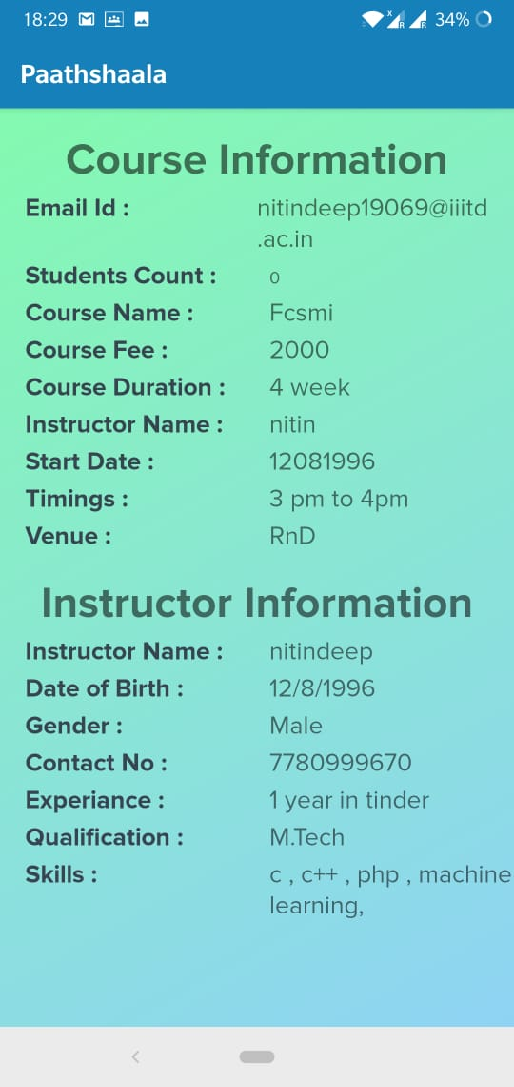

**Information Page**

On clicking ‘More information’ a new page opens which displays ‘Course Information’ and ‘Instructor Information’, which contains the details about the course and details about the instructor respectively.

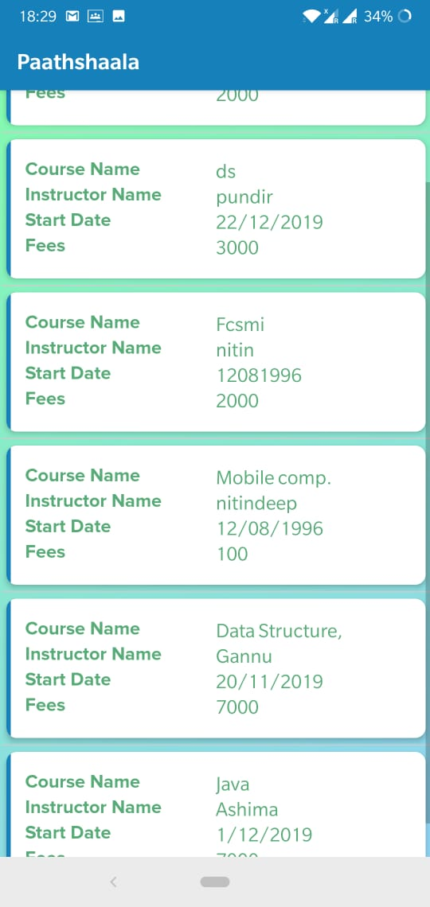

**Published Courses**

This page displays all the published courses of all the subjects by all the instructors.

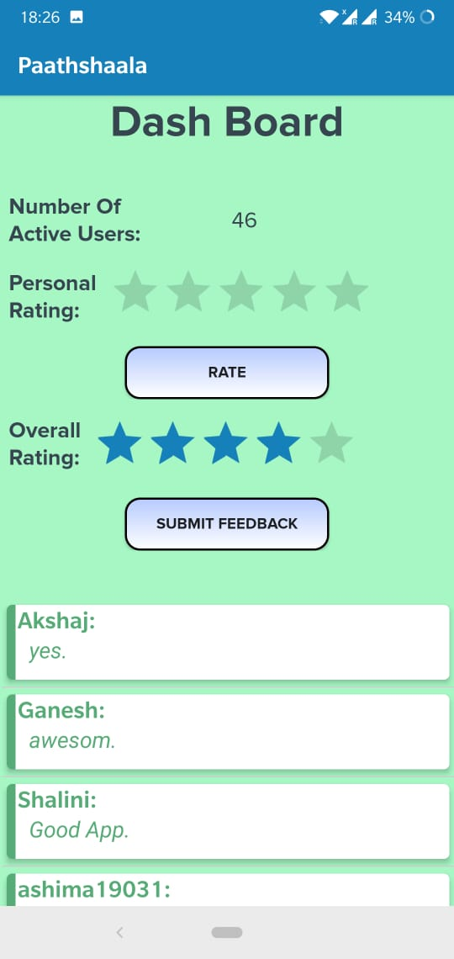 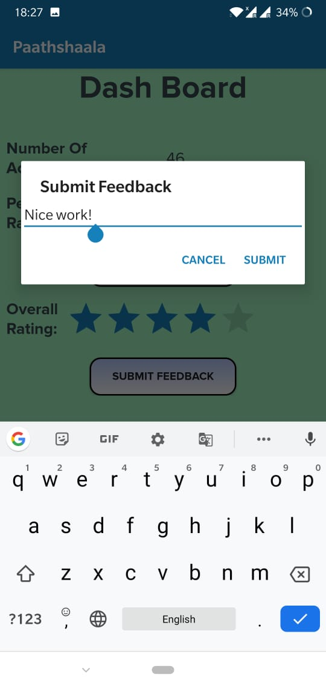

**Dash Board**

It shows the number of current users. User can rate the app under ‘Personal Rating’. User can also view the ‘Overall Rating’ of the app. Feedback can be submitted in ‘Submit Feedback’. Feedback given by all the users is displayed.

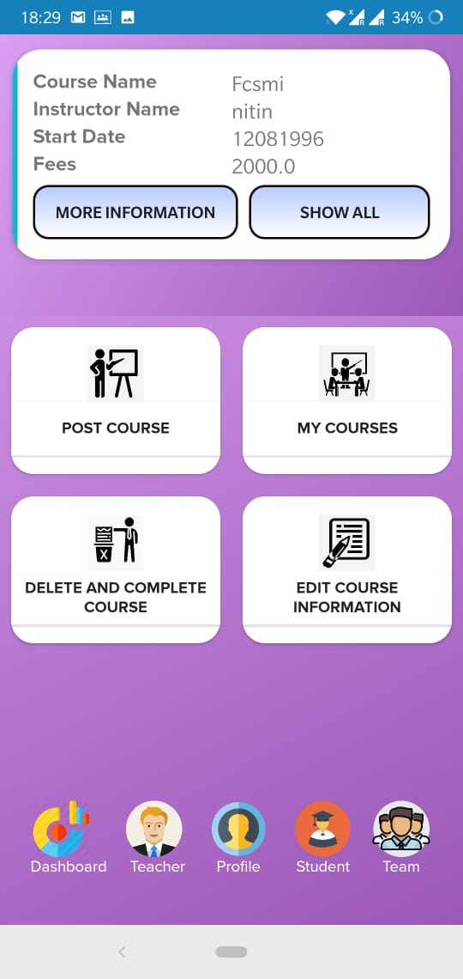 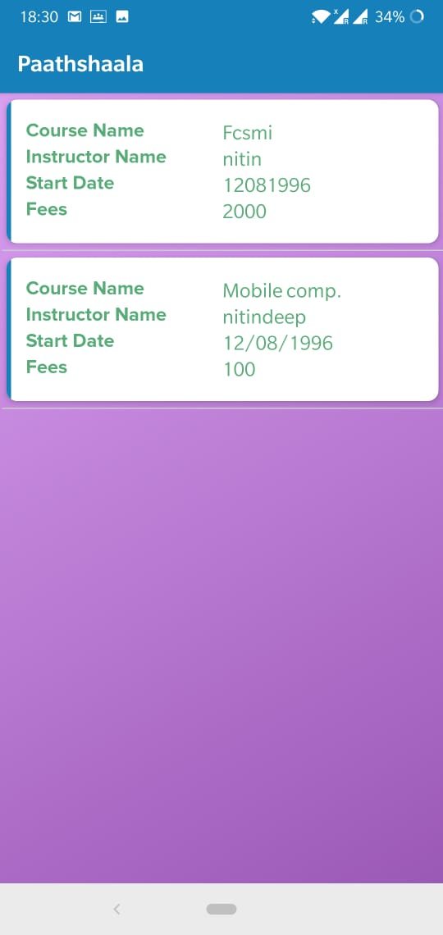

**Teacher’s Home Page**

On clicking ‘Teacher’ icon user can access a new page, it contains

POST COURSE: a teacher can post a new course by clicking it.

MY COURSES: it contains all the courses already posted by the instructor.

DELETE AND COMPLETE COURSE: instructor can delete a course or can complete its duration under this.

EDIT COURSE INFORMATION: instructor can edit the course information under this.

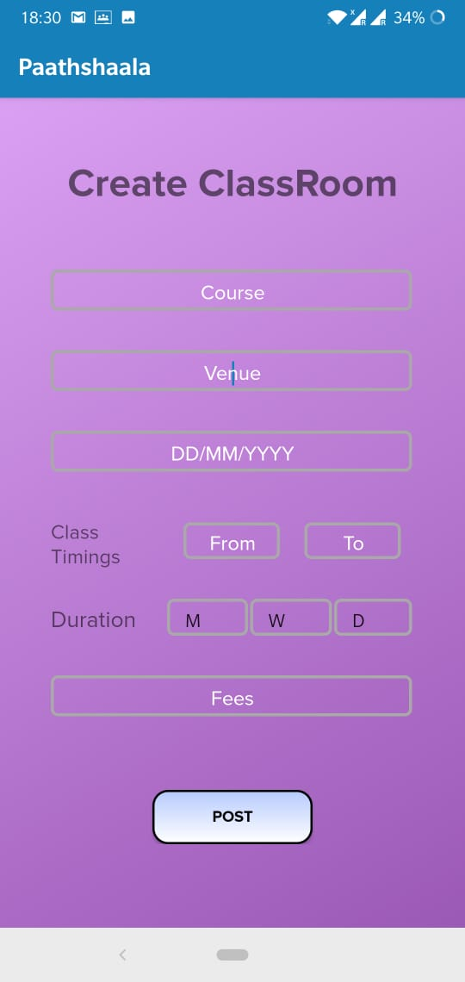 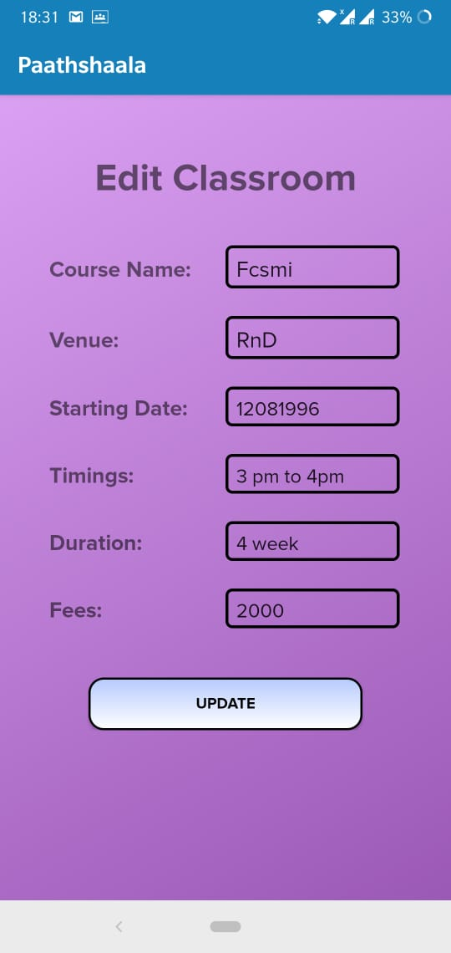

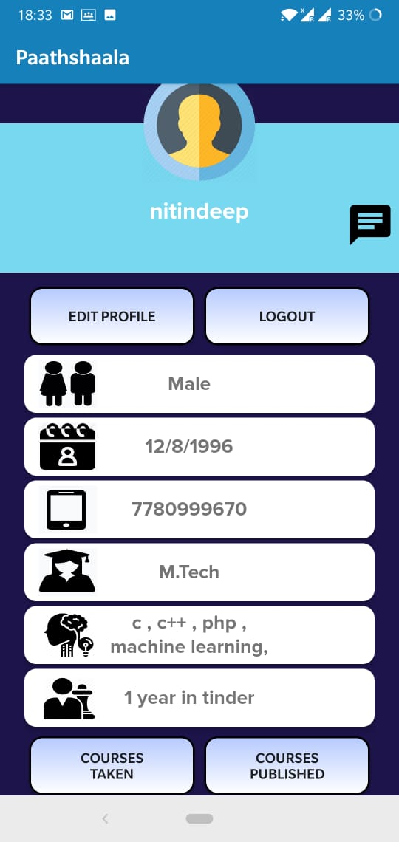 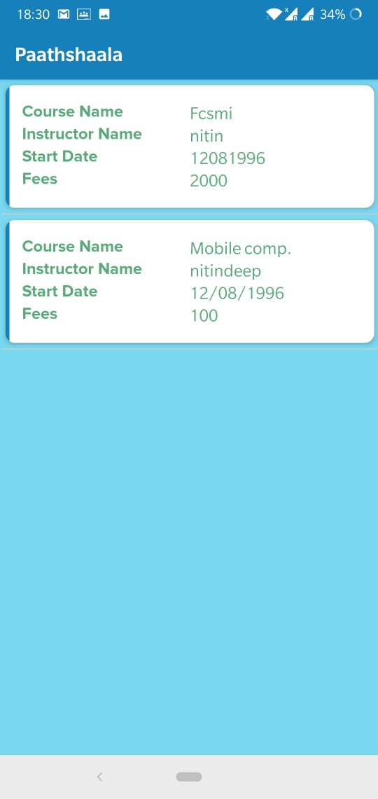

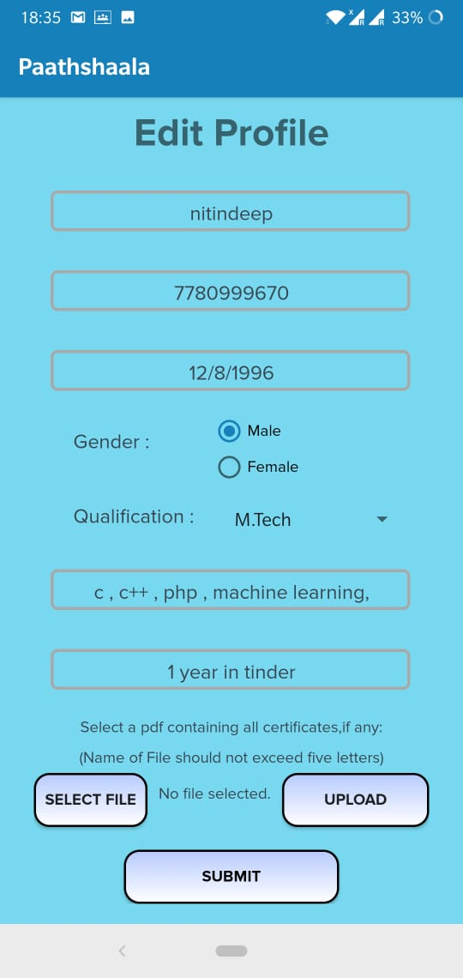 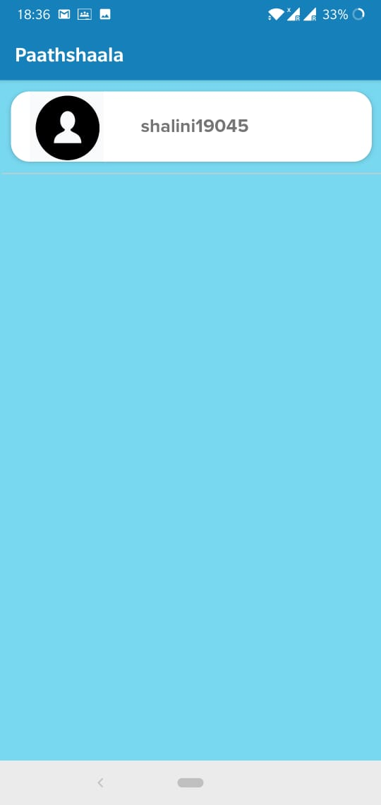

**User Profile**

This page opens up on clicking the ‘Profile’ icon. This page displays the information about the user. A user can edit his/her profile under ‘EDIT PROFILE’, he/she can view the courses taken up by him/her under ‘COURSES TAKEN’(if the user is student), he/she can view the courses published by him/her under ‘COURSES PUBLISHED’(if the user is instructor). User can also view his/her chats with other users .User can Logout by clicking ‘LOGOUT’

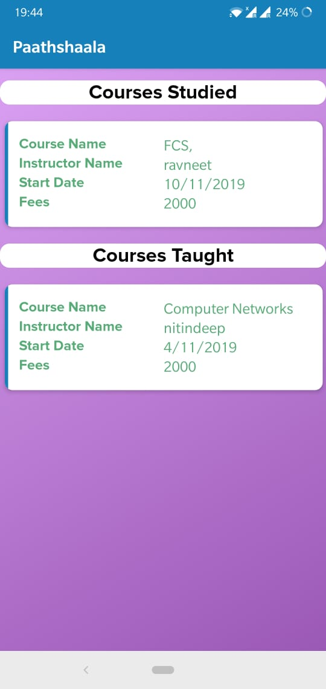

**Courses Completed**

Students can see the courses completed by them and instructors can see the courses taught by them

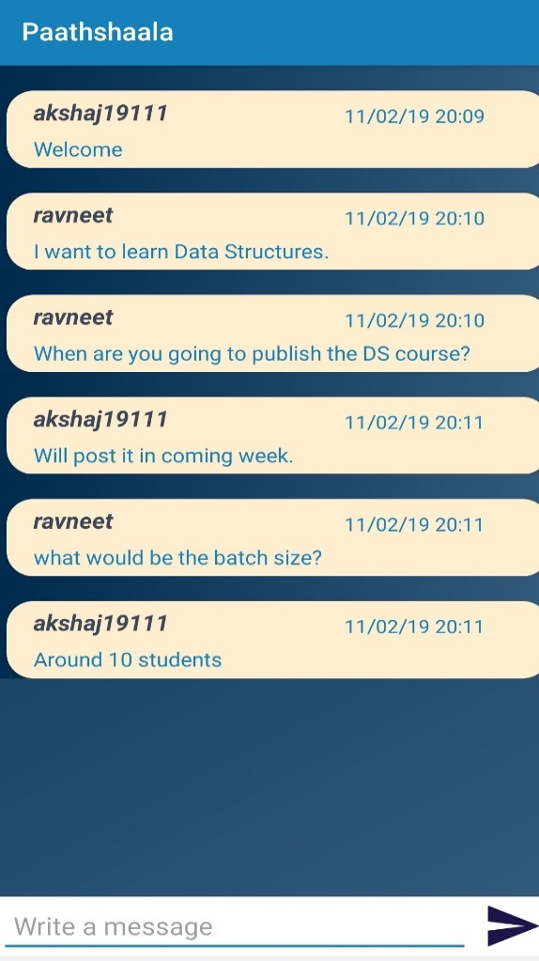

**Private Chat**

Students can also communicate with the instructor through private chat which opens on clicking ‘Request’.

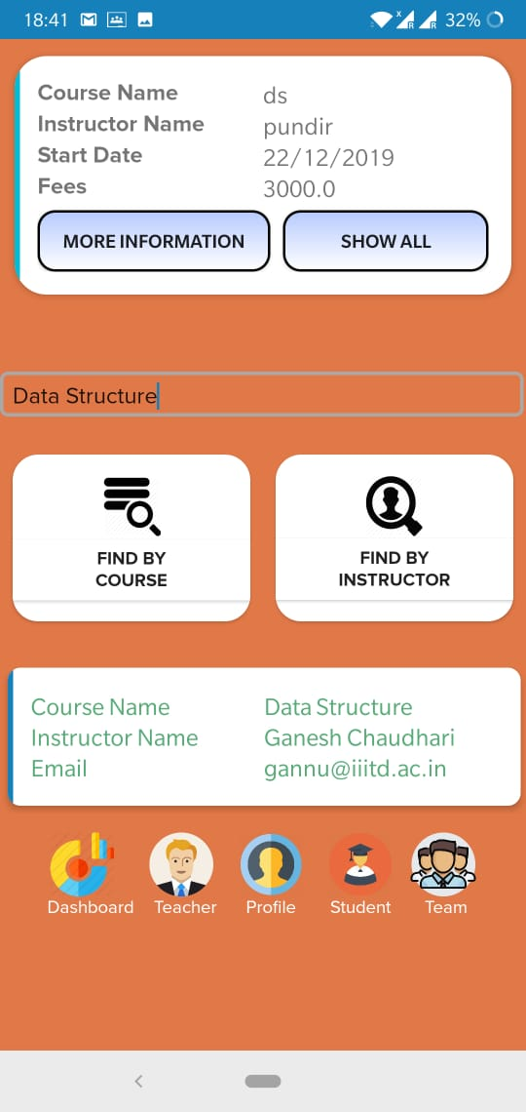

**Student’s Home Page**

On clicking ‘Student’ a new page is opened, here the student can find the courses under ‘FIND BY COURSE’, and can find the courses uploaded by specific instructor under ‘FIND BY INSTRUCTOR’

.